Program 28

Write a program to input a dictionary and arrange the Dictionary into Ascending order?

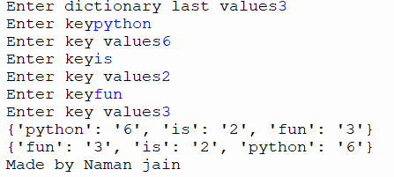

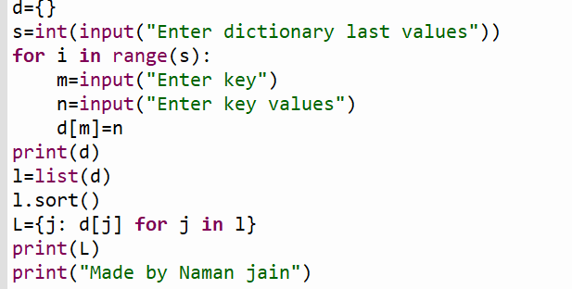

Program 29

Write a program to input a dictionary and then find the size of the dictionary?

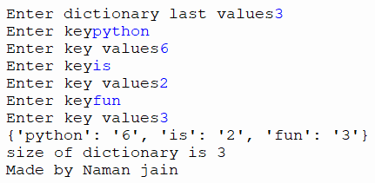

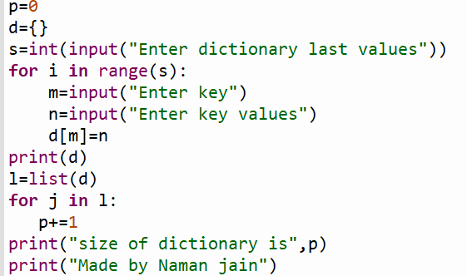

Program 30

Write a program to input a dictionary from user and then print max and min values of dictionary?

